**Pistol Selection: Makarov PM**

**Criteria for Choosing a Pistol Model:**

1. **Caliber:** The caliber of a pistol affects its stopping power, recoil, and suitability for different types of shooting. The Makarov PM uses a 9mm cartridge, which offers a balance between power and manageable recoil.
2. **Design Complexity:.** The Makarov PM, with its straight blowback action, is a model of design simplicity. This type of action has fewer moving parts, which reduces the likelihood of mechanical failure and simplifies field stripping and maintenance—crucial for reliability under adverse conditions.
3. **Availability of Technical Specifications:** 
   1. **Action**: It operates on a straight blowback action, which is simple and reliable.
   2. **Barrel Length**: The barrel is typically about 3.68 inches (93.5 mm) long.
   3. **Magazine Capacity**: The standard magazine capacity is 8 rounds.
   4. **Overall Length**: The overall length of the pistol is approximately 6.36 inches (161.5 mm).
   5. **Weight**: The Makarov PM weighs about 730 grams (26 oz) when unloaded.
   6. **Material**: It has a steel frame and slide with a blued finish, contributing to its robustness.

**Selection Process and Considerations:**

Older pistol models, such as the Makarov PM, are often valued for their straightforward and uncomplicated mechanisms. The simplicity of their design, stemming from fewer moving parts and a direct blowback action, makes them ideal for projects where ease of maintenance and reliability are prioritized. This simplicity also reduces the likelihood of mechanical failure.

For models like the Makarov PM, extensive technical documentation is available due to their long history of use and significant presence in military and police forces across multiple countries. This documentation can be crucial for understanding the design intricacies and operational mechanics, facilitating accurate replication or adaptation in project modeling.

**Main pistol components:**

1. Magazine
2. Receiver
3. Recoil spring
4. Slide
5. Projectile

**Assumptions:**

1. For simplification we will consider the barrel, magazine and receiver as 1 component named receiver.
2. Total components to be analysed are 3 namely: recoil spring, slide, receiver.
3. The motion of the mechanical system is two-dimensional, the rotational forces are assumed to be 0.
4. The modelling is being done from the point the trigger is pulled, namely t=0, to the point the recoil spring and slide moves back into place chambering the next bullet, namely t=tf.
5. If both hands are on the grip the stiffness and damping coefficients of hands will simply double.
6. Coriolis and centrifugal forces are neglected in the equations of motion.
7. Dry friction C1, C2 have been assumed constant.
8. For ease of simulation, the impact that the slide makes with the receiver is assumed to be purely elastic meaning no energy is lost (in real scenarios, the slide moves forward with a velocity with respect to the restitution velocity coefficient that occurs when two bodies impact).

**Definition of physical parameters:**

C–center of mass

C’– point perpendicular to the slide mass axis and shortest distance from point H

Chx, Chy–Damping coefficients of hand(s)

C1, C2– Dry friction of Slide with receiver

Fdx, Fdy–Reaction forces of hand

F(t) –force applied by the bullet onto the gun

H– point where resistive forces are applied by hand due to recoil

I –mass moment of inertia of the pistol

Khx, Khy–Stiffness coefficient of hand(s)

K1–Damping coefficients of recoil spring

K2–Damping coefficients of recoil spring

L1, L2–Coordinate of point H at rest position

m–mass of receiver  
m1–mass of slide mass and spring

p– distance between point C’ and C

q–displacement between point H and C’

x, y – fixed coordinates

x1, y1– inertial coordinates

Φ –the rotational angle of the gun after bullet has been shot

**Formulation of equation of motion for pistol components:**

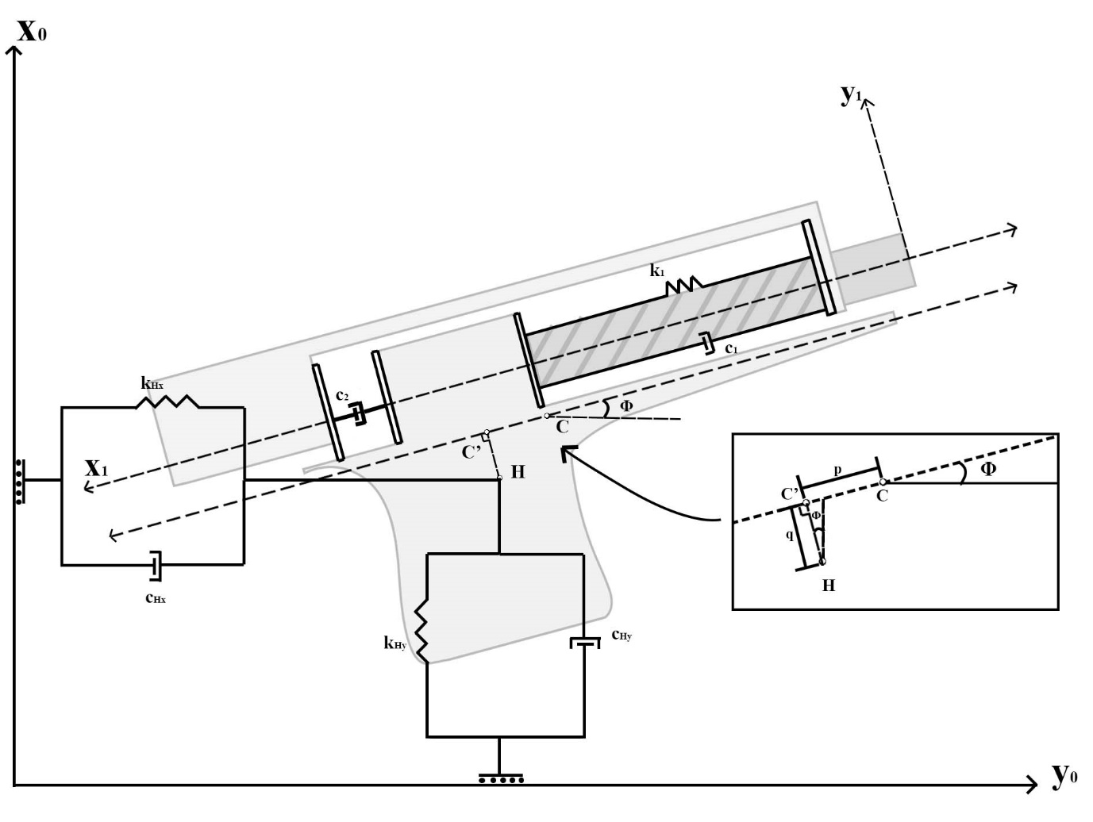

**Calculations of Parameters**

M1=0.292kg

M=0.730-0.292=0.438kg

Dry friction C1, C2 =  μ x N

N= mg = 0.292 x9.81 = 2.86N

 μ steel to steel = 0.6

C1, C2 = 0.6 x 2.86 = 1.72N

K1 = F/d

Recoil spring rate of marakov pm = 16lbf = 71N

Backwards travel of the spring = 0.87 inches = 0.0221 m

K1 = 71/0.0221 = 3212.7N/m

Impulse force F(t) = recoil force of bullet

m1v1=m2v2 🡪 0.0075x380=0.73xv2 🡪 v2= 3.90 m/s

recoiling time = 0.002s

F(t) = 0.73x3.90/0.002 = 1424N

Khx = 98.2KN/m

Chx =10.60Ns/m

Khy = 180Nm/rad , r = 0.8623

Khy = 180/0.8623 = 208.74 N/m

Chy =0.002xKhy = 0.417Ns/m

L2 = 146.53 cm = 1.465m

L1 = 37.54+48.69 = 86.23cm = 0.8623m

I = 0.00635 kgm^2

s =3cm = 0.03m

z =1cm = 0.01m

**Governing Equations**

$$F_{Hx}=-K_{Hx}\left(x-p cosϕ+q sinϕ-L_{1}\right)-C_{Hx}(\dot{x}+p sinϕ\dot{ϕ}+q cosϕ\dot{ϕ})$$

$$F_{Hy}=-K_{Hy}\left(y-p sinϕ+q cosϕ-L_{2}\right)-C_{Hy}(\dot{y}+p cosϕ \dot{ϕ}+q sinϕ\dot{ ϕ})$$

$$m_{1}\ddot{x_{1}}+\left(c_{1}+c_{2}\right)sign(\dot{x_{1}})+k_{1}x_{1}=F(t)$$

$$m\ddot{x}=F_{Hx}+\left(c_{1}+c_{2}\right)sign\left(\dot{x_{1}}\right)cosϕ+k_{1}x_{1}cosϕ$$

$$m\ddot{y}=F_{Hy}+\left(c_{1}+c_{2}\right)sign\left(\dot{x_{1}}\right)sinϕ+k_{1}x_{1}sinϕ$$

$$I\ddot{ϕ}=F_{Hx}\left(p sinϕ+q cosϕ\right)-F_{Hy}(p cosϕ-qsinϕ)$$

**Integration of external factors and initial conditions:**

**External Factors:**

1. The resistive forces generated by the hand due to the recoil are calculated and used in the final equations of motion.

**Initial conditions:**

1. The forces acting on the pistol are zero, even from the gripping of the pistol by the person.
2. There is no rotational forces or torques on the pistol, the motion is purely two dimensional.

**Simulation**

**Implementation of the Mathematical Model in a Simulation Environment:**

**Visualization of Pistol Behavior:**

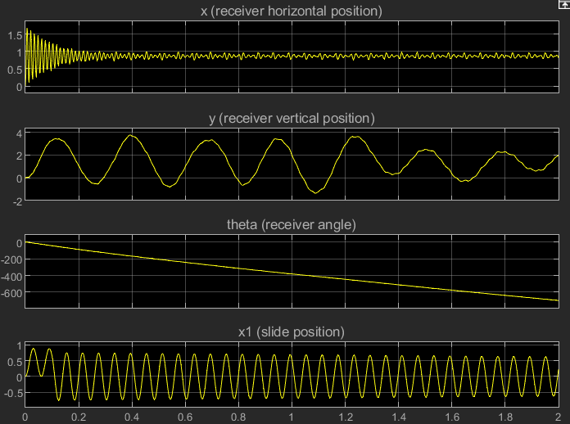

**Analysis and Discussion of Simulation Results:**

The dynamical model of the Makarov PM pistol is limited by a lack of specific experimental data, uncertainties in generalized coefficient values such as stiffness and damping, and necessary simplifications such as treating complex parts as simple geometric shapes. These factors can lead to inaccuracies in predicting behaviors like recoil and mechanical stress responses. Without comprehensive physical testing and precise data on material properties, the model's predictions may not fully align with the real-world performance of the firearm, especially under varied operational conditions.

Despite these limitations, the dynamical model of the Makarov PM pistol provides valuable insights into the basic operational mechanics and interactions within the firearm. It offers a foundational understanding of how components like the slide, frame, and barrel respond to firing stresses, which is useful for preliminary design assessments and educational purposes. The model also facilitates simulations that can predict potential points of failure and areas for improvement in firearm design, serving as a critical tool in the initial stages of engineering development and innovation.

**References**

CAD model of Marakov PM

<https://grabcad.com/library/makarov-pm-pistol-1>

Dynamical model of a training pistol

<https://www.sciencedirect.com/science/article/pii/S2214914719301163#sec6>

Modelling and simulation of pistol dynamics

https://www.researchgate.net/publication/277592816_Modeling_and_numerical_simulation_of_semi-automatic_pistol_dynamics

Spring rate of Marakov PM

<https://www.gunsprings.com/MAKAROV/ALL+VERSIONS+9mm+MAKAROV+(9x18)/cID1/mID39/dID166>

Static and kinetic friction of steel on steel

<https://hypertextbook.com/facts/2005/steel.shtml#:~:text=The%20coefficient%20of%20static%20friction,involves%20many%20processes%20and%20stages>.

Stiffness and damping coefficients of the upper arm

<https://www.researchgate.net/publication/280735232_A_STUDY_ON_DAMPING_COEFFICIENTS_OF_A_VIBRATORY_MODEL_OF_HUMAN_BODY>

Stiffness and damping coefficients of the shoulder muscle

<https://www.researchgate.net/figure/Stiffness-and-damping-coefficients-of-the-muscles_tbl1_304915639>